

**King Abdulaziz University**

**Faculty of Economic and Administration**

**Information System Department**

**CPIS 340**

**Students names and ID:**

Muhammad Sagr ALzahrani 1935819

Mohammed Ahmed ALamoudi 1935399

Ali Abduh Ali 1936122

Anas Saad ALqarni 1846879

Faris Ahmed Bakry 1743775

**Supervised by:**

DR. Mohammed El Eliemy

**Hotel reservation project**

Project Description

‏Project idea: a website through which several hotels are displayed and the user reserve a hotel room in one of the hotels or cancels the reservation and showing the available rooms for the reservation and the reserved rooms in each hotel

The tables used in the database are:

* The hotel
* Hotel rooms
* Employees
* Invoices
* Customers
* The restaurant
* Meals

The relationships between tables are:

* One to many Relation (hotel -room)
* One to many Relation (hotel-employees)
* One to many Relation(restaurants-meals)
* One to One Relation (customers-invoice)

clarification of the table

The table includes the following entities and their attributes:

Hotel: It contains many rooms available for reservation and not available and a restaurant (hotel number-hotel name-hotel classification-number of hotel rooms-hotel address)

Rooms: (room number - hotel number - floor number - reservation price - room condition) Employees: (employee ID - employee name - employee salary - job description [employee type] - hotel number)

Invoices: (invoice number - invoice value - invoice issuance date - hotel number - the number of the employee who issued the invoice)

Customers (customer number - customer name - hotel number in which the reservation was made - room number booked - invoice number)

Restaurant: (restaurant number - restaurant name - hotel number)

Meals: (meal number-meal name-meal description-meal price-restaurant number)

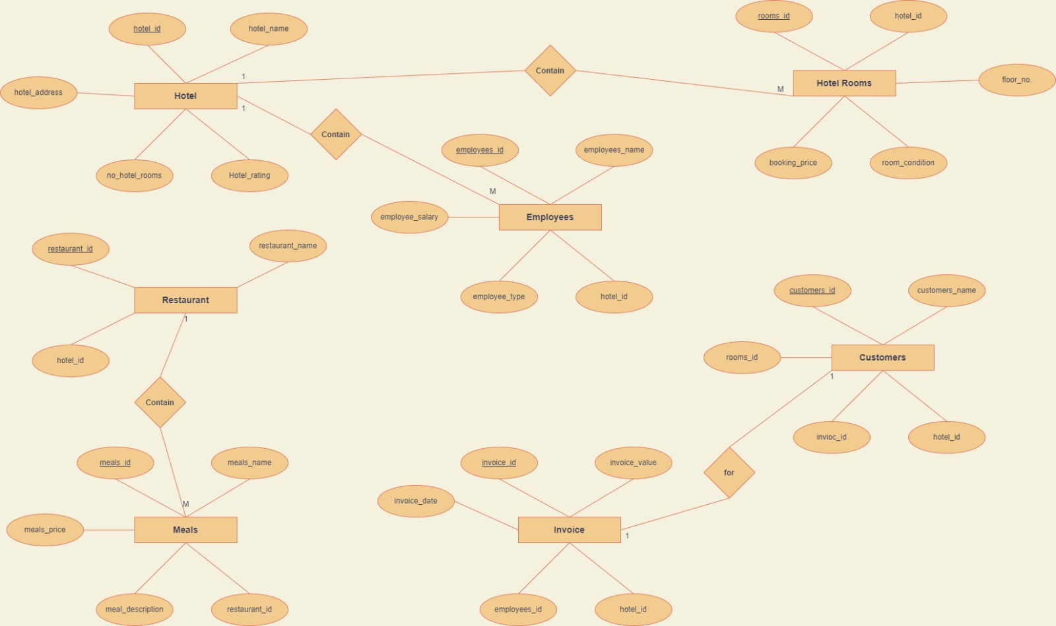

**ERD**

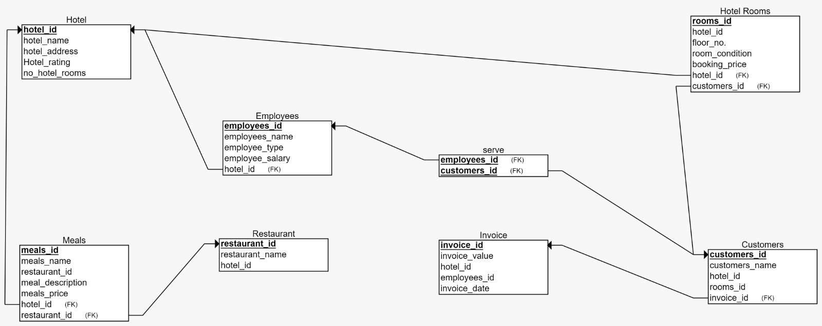

**Database Schema**

**Hotel table description:**

|  |  |  |
| --- | --- | --- |
| **constraint** | **datatype** | **field** |
| **PK** | **int** | **hotel_id** |
| **Not null** | **varchar** | **hotel_name** |
| **Not null** | **int** | **hotel_rating** |
| **Not null** | **int** | **nnumber_hotel_rooms** |
| **Not null** | **varchar** | **hotel_address** |

**Hotel Rooms table description:**

|  |  |  |
| --- | --- | --- |
| **constraint** | **datatype** | **field** |
| **PK** | **int** | **rooms_id** |
| **FK** | **int** | **hotel_id** |
| **Not null** | **int** | **floor_number** |
| **Not null** | **int** | **booking_price** |
| **Not null** | **int** | **room_condition** |

**Employees table description:**

|  |  |  |
| --- | --- | --- |
| **constraint** | **datatype** | **field** |
| **PK** | **int** | **employees_id** |
| **FK** | **int** | **hotel_id** |
| **Not null** | **varchar** | **employees_name** |
| **Not null** | **int** | **employee_salary** |
| **Not null** | **varchar** | **employee_type** |

**Customers table description:**

|  |  |  |
| --- | --- | --- |
| **constraint** | **datatype** | **field** |
| **PK** | **int** | **customers_id** |
| **Not null** | **varchar** | **customers_name** |
| **FK** | **int** | **hotel_id** |
| **FK** | **int** | **rooms_id** |

**Invoice table description:**

|  |  |  |
| --- | --- | --- |
| **constraint** | **datatype** | **field** |
| **PK** | **int** | **Number_id** |
| **FK** | **int** | **employees_id** |
| **FK** | **int** | **hotel_id** |
| **FK** | **int** | **customers_id** |
| **Not null** | **date** | **invoice_date** |
| **Not null** | **int** | **invoice_value** |

**Restaurant table description**

|  |  |  |
| --- | --- | --- |
| **constraint** | **datatype** | **field** |
| **PK** | **int** | **restaurant_id** |
| **Not null** | **varchar** | **restaurant_name** |
| **FK** | **int** | **hotel_id** |

**Meals table description:**

|  |  |  |
| --- | --- | --- |
| **constraint** | **datatype** | **field** |
| **PK** | **int** | **meals_id** |
| **Not null** | **varchar** | **meals_name** |
| **Not null** | **varchar** | **meal_description** |
| **Not null** | **int** | **meals_price** |
| **FK** | **int** | **restaurant_id** |

**CREATE TABLE Employees (**

**employees_id INT(5) NOT NULL,**

**employees_name VARCHAR(255) NOT NULL,**

**employee_type INT(5) NOT NULL,**

**employee_salary INT(5) NOT NULL,**

**hotel_id INT(5) NOT NULL,**

**PRIMARY KEY (employees_id),**

**FOREIGN KEY (hotel_id) REFERENCES Hotel(hotel_id)**

**)**

**CREATE TABLE Hotel (**

**hotel_id INT(5) NOT NULL,**

**hotel_name VARCHAR(255) NOT NULL,**

**hotel_address VARCHAR(255) NOT NULL,**

**Hotel_rating INT(5) NOT NULL,**

**no_hotel_rooms INT(5) NOT NULL,**

**PRIMARY KEY (hotel_id)**

**)**

**CREATE TABLE Invoice (**

**invoice_id INT(5) NOT NULL,**

**invoice_value INT(5) NOT NULL,**

**hotel_id INT(5) NOT NULL,**

**employees_id INT(5) NOT NULL,**

**invoice_date INT(5) NOT NULL,**

**PRIMARY KEY (invoice_id)**

**FOREIGN KEY (hotel_id) REFERENCES Hotel(hotel_id)**

**)**

**CREATE TABLE Restaurant (**

**restaurant_id INT(5) NOT NULL,**

**restaurant_name varchar(255) NOT NULL,**

**hotel_id INT(5) NOT NULL,**

**PRIMARY KEY (restaurant_id),**

**FOREIGN KEY (hotel_id) REFERENCES Hotel(hotel_id)**

**)**

**CREATE TABLE Meals (**

**meals_id INT(5) NOT NULL,**

**meals_name VARCHAR(255) NOT NULL,**

**restaurant_id INT(5) NOT NULL,**

**meal_description VARCHAR(255) NOT NULL,**

**meals_price FLOAT NOT NULL,**

**hotel_id INT(5) NOT NULL,**

**PRIMARY KEY (meals_id),**

**FOREIGN KEY (hotel_id) REFERENCES Hotel(hotel_id), FOREIGN KEY (restaurant_id) REFERENCES Restaurant(restaurant_id)**

**)**

**CREATE TABLE Customers (**

**customers_id INT(5) NOT NULL,**

**customers_name VARCHAR(255) NOT NULL,**

**hotel_id INT(5) NOT NULL,**

**rooms_id INT(5) NOT NULL,**

**invoice_id INT(5) NOT NULL,**

**PRIMARY KEY (customers_id),**

**FOREIGN KEY (invoice_id) REFERENCES Invoice(invoice_id),**

**FOREIGN KEY (hotel_id) REFERENCES Hotel(hotel_id) )**

**CREATE TABLE serve (**

**employees_id INT(5) NOT NULL,**

**customers_id INT(5) NOT NULL,**

**PRIMARY KEY (employees_id, customers_id),**

**FOREIGN KEY (employees_id) REFERENCES Employees(employees_id),**

**FOREIGN KEY (customers_id) REFERENCES Customers(customers_id)**

**)**

**CREATE TABLE Hotel_Rooms (**

**rooms_id INT(5) NOT NULL**

**, hotel_id INT(5) NOT NULL,**

**floor_no INT(5) NOT NULL,**

**room_condition INT(5) NOT NULL,**

**booking_price INT(5) NOT NULL,**

**customers_id INT(5) NOT NULL,**

**PRIMARY KEY (rooms_id),**

**FOREIGN KEY (hotel_id) REFERENCES Hotel(hotel_id),**

**FOREIGN KEY (customers_id) REFERENCES Customers(customers_id)**

**)**

